**SOCIAL DISTANCING PROJECT**

Team Name: Hackohoopz

**Submitted by Somarathi Aishwarya**

**Guided by Dr Arundhati Das**

**Date of Submission 8th July,2023.**

**Abstract**

Social distancing has emerged as a crucial preventive measure during the COVID-19 pandemic. This abstract provides a concise overview of the concept and its impact. Social distancing involves reducing close physical contact between individuals to minimize the spread of infectious diseases. It has been shown to effectively reduce transmission rates, hospitalizations, and mortality. However, it has also led to adverse effects on mental health, social interactions, and the economy. In this project we are using the YOLOv3algorithm. YOLO (You Only Look Once) is a real-time object detection algorithm known for its speed and accuracy.

**Introduction**

Covid-19 is the scientific name of corona virus. Till now around 27 crore people were affected by this pandemic including 5 Lakh deaths as per WHO statistics. This disease is considered as a pandemic when it is spread to different countries and caused fatalities. The spread of disease is due to the contact of infected persons with other persons. So, to detain the spread of virus we require an effective monitoring system which monitors people in public places. Monitoring social distancing is very tedious if done manually as it is difficult to monitor continuously by human naked eye. So, this is implemented automatically by our software tool which not only monitors people but also highlight the persons who are violating social distancing norms with red color boxes. We use CCTV cameras for automatic monitoring of people. This tool can be used in places like Airport, malls etc.

The need for developing this tool is to help people and the government to identify and alert people who are being the main cause for the spread of epidemic. We set minimum distance as 50 pixels with minimum thresh hold as 0.3 and minimum configurations as 0.3 in this project. Libraries used for the project includes OpenCv, imutils and NumPy. We have used OpenCv for image processing functionalities. It is an open-source library, some functionalities of imutils used in project are show (for displaying images) and resize. The math package is used for importing distance metrics i.e., Euclidean distance, NumPy (numerical python) is used for working with arrays and argparse is used for passing input video as a command line argument.

**Motivation**

We are delighted that we have been selected for this internship. From that very moment we have been motivated for every second. Furthermore, by collaborating with Intel, we gain access to cutting-edge technologies and expertise, enabling us to explore the full potential of deep learning in the field of road object detection. The opportunity to work with industry leaders is like a wish come true for any undergraduate student.

**Prior Work**

Social distancing as a preventive measure during disease outbreaks has been a topic of study and implementation prior to the COVID-19 pandemic. While COVID-19 has significantly heightened the attention and global implementation of social distancing, previous outbreaks and pandemics have provided valuable insights and prior work in this area. Building upon the prior work in social distancing, our project aims to contribute to the existing knowledge by implementing and evaluating the YOLOv3 algorithm for accurate and real-time detection. By leveraging the advancements in deep learning and utilizing annotated datasets. By the advancements in deep learning and utilizing annotated datasets, we strive to develop a robust system that can detect and monitor people in crowd effectively and social distance between them.

**Our Approach**

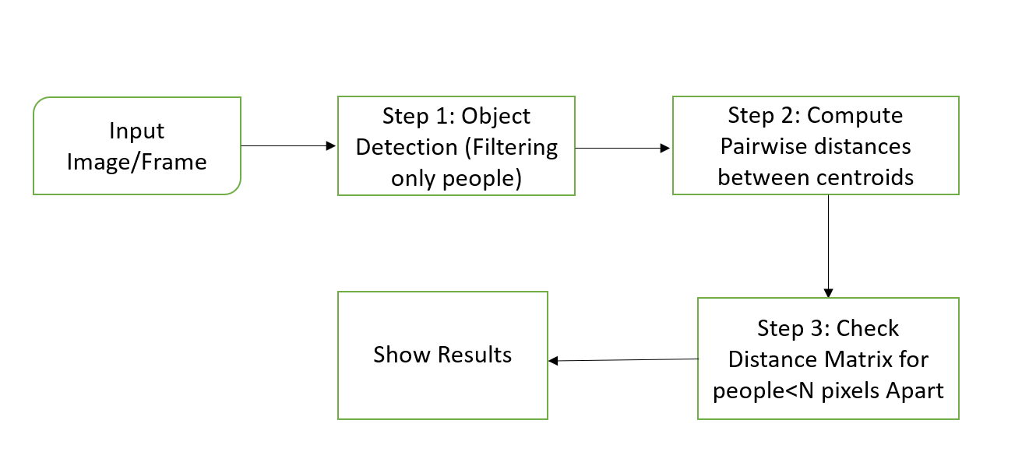We have used YOLO V3 (Version-3) model which is pre-trained. We set minimum distance as 50 pixels with minimum thresh hold as 0.3 and minimum configurations as 0.3 in this project. Libraries used for the project includes OpenCv, imutils and NumPy. We have used OpenCv for image processing functionalities. It is an open-source library, some functionalities of imutils used in project are show (for displaying images) and resize. The math package is used for importing distance metrics i.e., Euclidean distance, NumPy (numerical python) is used for working with arrays is used for passing input video as a command line argument. Here the input mp4 file is given to the Code the output will be displayed in three colours.

**Results:**

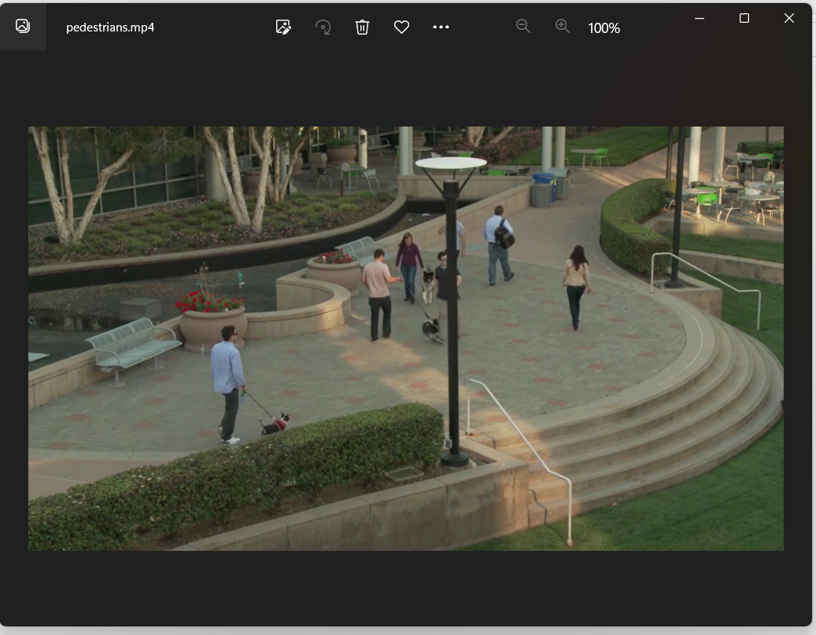Input:mp4 file

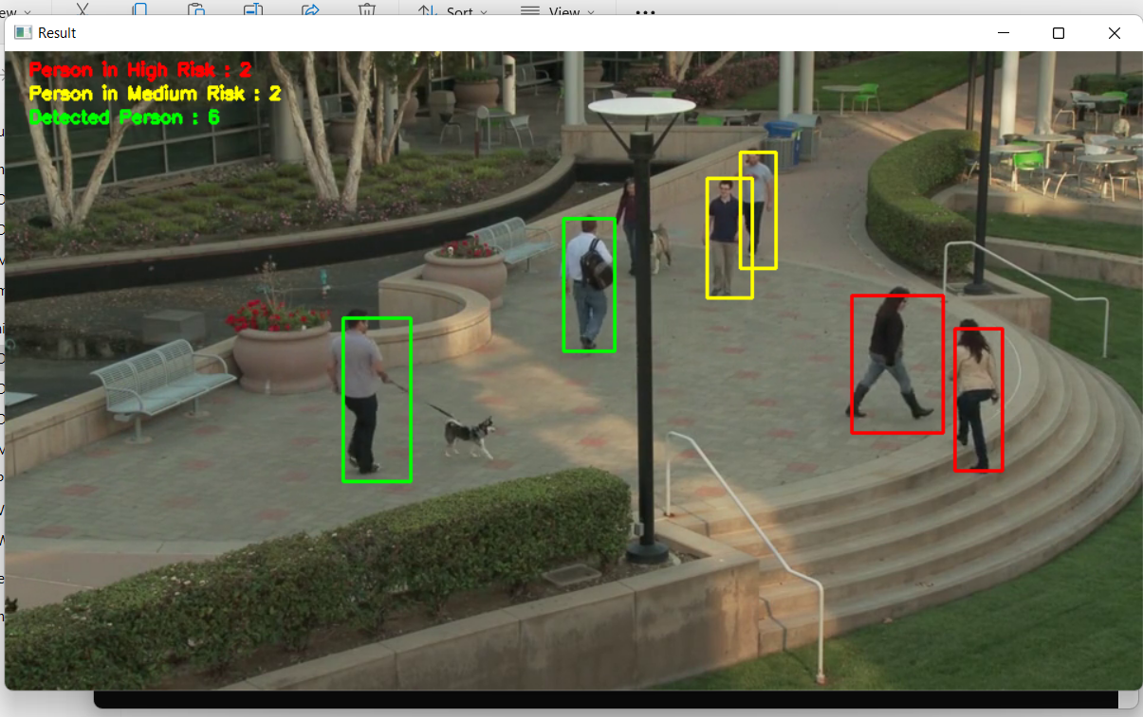Output:

**References**

* Covid-19 information available: <https://covid19.who.int/>Ministry of Health Malaysia (MOHM) Official Portal.
* COVID-19 (Guidelines), [online] Available: https://www.moh.gov.my/index.php/pages/view/2019-ncov-wuhan-guid elines.
* 4. J. Redmon, S. Divvala, R. Girshick and A. Farhadi, "You only look once: Unified real-time object detection", Proceedings of the IEEE conference on computer vision and pattern recognition, pp. 779-788, 2016.
* K. Simonyan and A. Zisserman, Very deep convolutional networks for large-scale image recognition, 2014.
* YOLOv3 performance curve available: https://images.app.goo.gl/KSZ8EgaahULzQs2B7 Simonyan K, Zisserman A. Very deep convolutional networks for large-scale image recognition. arXiv preprint arXiv:14091556. 2014
* D.T. Nguyen, W. Li and P.O. Ogunbona, "Human detection from images and videos: A survey", Pattern Recognition, vol. 51, pp. 148-75, 2016.

**Link to the solution:**